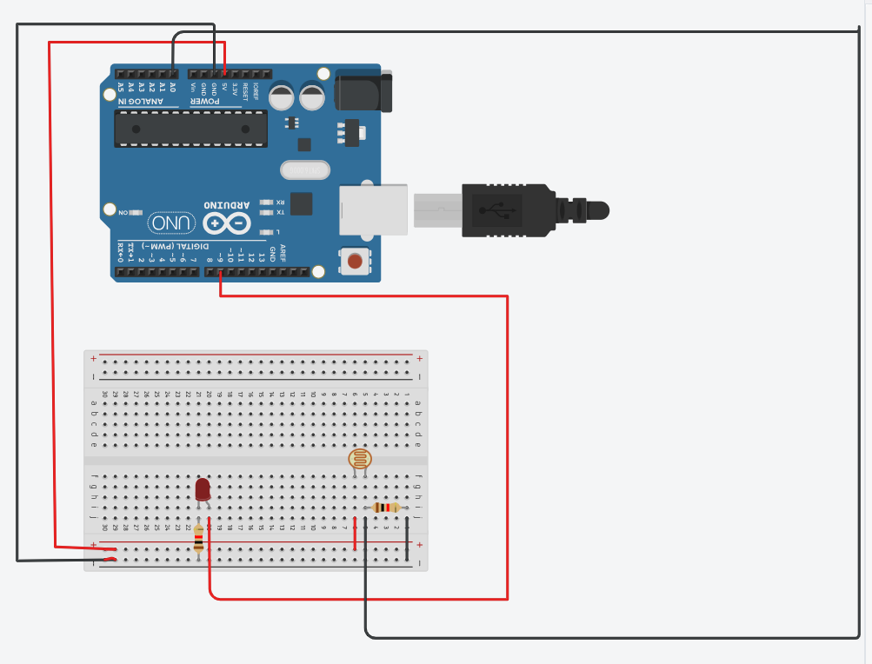

const int ldrPin= A0;
const int ledPin = 9;
int ldrValue = 0;
int threshold = 500;

void setup() {
pinMode(ledPin, OUTPUT);
Serial.begin(9600);
}

void loop() {
ldrValue = analogRead(ldrPin);

Serial.print("LDR Value: ");
Serial.println(ldrValue);

if (ldrValue < threshold) {
digitalWrite(ledPin, HIGH);
Serial.println("Environment: DARK LED ON");
} else {
digitalWrite(ledPin, LOW);
Serial.println("Environment: DARK LED OFF");
}
delay(300); // Wait half a second before next reading
}

Conclusion : The Tinkercad LDR experiment showed that the LDR’s resistance decreases when light increases and rises when light decreases. This change directly affects the circuit’s output, proving that an LDR can effectively detect variations in light intensity.

